MINUTES OF THE BUFFALO COUNTY BOARD OF COMMISSIONERS
Fiscal Meeting – December 27, 2022
A fiscal meeting of the Buffalo County Commission was held on December 27, 2022, at 11:30am.
Chairman Lloyd Lutter called the meeting to order with Commissioners Donita Loudner and Dawn Cable present.
Also present were Debra Morrison, Buffalo County Auditor, Steve Fox, Deputy States Attorney, and several concerned citizens.
Loudner moved to accept the agenda, seconded by Cable. Motion carried by all voting Aye.
Loudner moved to approve the minutes of the previous meeting, seconded by Cable. Motion carried by all voting Aye.
Commissioners discussed the following Contingency Transfer Resolution. Cable made a motion to approve the Contingency Transfer Resolution, seconded by Loudner. Motion Carried by all voting Aye.
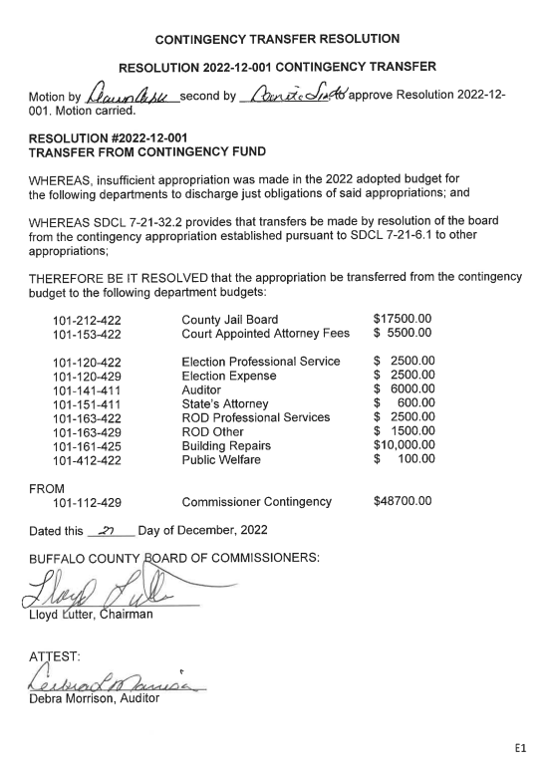
Loudner then called for executive session for personal issues at 10:15am, seconded by Cable. Commissioners resumed at 12:35pm and discussed a mental health bill.
Adjourned at 12:40pm.

ATTEST:
Debra Morrison, Buffalo County Auditor
APPROVED:
Lloyd Lutter, Chairman

