MINUTES OF THE BOARD OF BUFFALO COUNTY COMMISSIONERS, FEBRUARY 7, 2023
Chairman Dawn Cable called the meeting to order with Vice-Chair Donita Loudner and Commissioner Rex Zastrow present.
Also present were Steven Fox, Deputy States Attorney; Debi Ruiz, Central Dakota Times; and Debra Morrison, Buffalo County Auditor.
Zastrow moved to accept agendas, seconded by Loudner. Motion carried by all voting Aye.
Loudner moved to approve the minutes of the previous meeting, seconded by Zastrow. Motion carried by all voting Aye.
February 2023 Fuel bid from Total Oil, Inc. for Unleaded Bulk Price @ $3.41 per gallon, Ethanol Bulk Price @ $3.09, #1 Dyed Bulk Price Prem @ $4.26, and #2 Dyed Bulk Price Prem @ $3.58 per gallon. Motion to accept by Zastrow seconded by Loudner. Motion carried by all voting Aye. Highway Advisor Lloyd Lutter gave his report on the highway. Loudner moved to approve two members of the highway department to attend an upcoming MSHA Training in Mitchell; seconded by Zastrow. Motion carried by all voting Aye.
County Support/Weed Supervisor Lee Sinkie discussed highway department and job description. Sinkie discussed the District III/SDDOT. Loudner moved to approve the Highway Superintendent job description, seconded by Zastrow. Motion carried by all voting Ayes.
Sheriff Wayne Willman discussed contract with Brule County is going well. Discussed RAVE. Discussed the medical bills. When the medical bills come to the auditor, they should be directed to the sheriff regarding prisoner and medical items.
Auditor/ROD Debra Morrison reported there were four hospitalizations in January. Treasurers and Auditors reported matched for January. Presented the Check History Report and Month End Payroll report for January. Discussed Highway Superintendent job ad and how to proceed in the future regarding continuing the ads.
Loudner made a motion to renew a three year Rave Mobile Safety plan; Cable seconded. Zastrow voted No. Motion carried by Cable and Loudner voted Ayes. Zastrow voted no.
Zastrow made a motion to approve Dulcy Sinkie as the Director of Equalization. Motion failed due to lack of second.
Loudner made a motion to hire Lee Sinkie as the Director of Equalization; seconded by Cable. Zastrow voted No. Motion carried by Cable and Loudner voting Ayes, Zastrow voting no.
Zastrow made a motion to approve the resolution to update the contract information for the commission appointed designee for South Dakota Department of Public Safety – Wildland Fire Division; seconded by Loudner. Motion carried by all voting Ayes.

RESOLUTION
2023-01

A resolution of the Buffalo County Commissioners updating contact information for the commission appointed designees for South Dakota Department of Public Safety – Wildland Fire Division.
WHEREAS the designated appointees for Buffalo County the three commissioners currently serving and authorized designees as for the duration of their terms; and
WHEREAS the purpose defined by SDCL 41-20A-11.
NOW THEREFORE BE IT RESOLVED that the Buffalo County Commissioners appointing our commissioners as the county designees.
Approved by the County Commissioners on February 7, 2023
Signed by: /s/ Dawn Cable, Chairman
Attested by: /s/ Debra Morrison, Auditor

Commissioner Zastrow moved, and Commissioner Loudner seconded that the County take public testimony on whether the County should contract with owners of private roads within the County for the purpose of the County to provide maintenance on such private roads. Hearing will be held March 7, 2023, at 2:00pm. Motion carried by all voting Aye.
Discussion was held regarding Consumer Price Index for 2023 – Taxable 2024; Veterans Services Officer Memorandum of Understanding with Brule Contract ; SD Labor and Employment Laws regarding employee breaks; and the Certificate of Compliance with Spring Valley Hutterian Brethren, Inc. with no motions being made.
Discussion on Abernathy Legion Post and Radio Tower. Several members of the Legion Post presented the commissioners with an agreement. Topic was tabled until the March 7, 2023, meeting.
Loudner made a motion to move into executive session on personal/employment concerns at 2:51pm; seconded by Zastrow. Executive session closed at 3:27pm with no action taken.
Loudner made a motion to approve the vouchers; Seconded by Zastrow. Motion carried by all voting Ayes.
A&R TRUCK EQUIPMENT INC Supplies & Materials 849.39
AURORA-BRULE RURAL WATER Building Utilities 53.00
BRULE COUNTY TREASURER Inv #2023-2 2992.00
BRULE COUNTY TREASURER Inv #2023-1 1302.00
BRULE COUNTY TREASURER Inv #2023-3 2998.96
BRULE COUNTY TREASURER County Jail Board 310.00
CENTRAL DAKOTA TIMES 45.24
CENTRAL DAKOTA TIMES INV #58645 81.65
CENTRAL ELECTRIC COOPERATIVE ACCT 105422004 120.90
CENTRAL ELECTRIC COOPERATIVE ACCT 105422003 562.44
CENTRAL ELECTRIC COOPERATIVE ACCT 105422000 1310.79
CONNECTING POINT INV #422964 100.00
GAULKE LAWN SERVICE MAINTENANCE 56.60
HURON PLAINSMAN HP100244 477.40
YVETTE ISBURG Professional Services 3012.50
JEFF ARGO Professional Services 1167.90
JIM ANDERSON Professional Services 136.25
LINCOLN COUNTY TREASURER INV24721 60.60
LLOYD LUTTER Professional Services 175.00
MARCO TECHNOLOGIES LLC INV10798881 80.09
MCLEOD'S OFFICE SUPPLY INV #64740, 64969 250.07
MENARDS - MITCHELL INV #47998 74.79
MEYERINK FARM SERVICES INC Supplies & Materials 169.72
MIDSTATE COMMUNICATIONS 439.15
MICROFILM IMAGING SYSTEMS INC ROD Rental 2380.00
MICROFILM IMAGING SYSTEMS INC Hours Indexing 120.00
PENNINGTON COUNTY JAIL PRISONER TRANSPORT 95.88
QUILL CORPORATION INV #30622561 116.89
RAVE WIRELESS INC INV-48409 3000.00
SD DEPARTMENT OF HEALTH Public Health Laboratory 40.00
SOUTH DAKOTA SHERIFFS' ASSOC INV #22-0010344 558.44
STATE OF SOUTH DAKOTA DP312198 6.25
SDACO M & P 10.00
T-MOBILE Utilities 15.00
TOTAL OIL, INC Supplies 9725.86
TRUE DAKOTAN INV #21926 124.00

January End of Month Payroll
Function/Office/Department | Regular Pay:
Commissioner | $620.00
Commissioner | $620.00
Commissioner | $620.00
Auditor/Register of Deeds | $3,500.00
Treasurer | $3,675.00
States Attorney | $3,432.71
Sheriff | $4,583.33
Director of Equalization | $0.00
Weed Supervisor | $0.00
County Assistant | $2,256.00
Highway Superintendent | $4,900.00
Highway Assistant | $5,739.35
 | $29,946.39

Auditor Morrison distributed upcoming events and trainings for the commissioners.
Next commissioners meeting will be held on March 7, 2023, at 1:00pm.
Zastrow moved to adjourn the meeting at 3:30pm; seconded by Loudner. Motion carried with all voting Ayes.
ATTEST: /s/ Debra Morrison; Buffalo County Auditor
APPROVED: /s/ Dawn Cable, Buffalo County Chairman

Notice of Public Hearing
Maintenance of Private Roads
It is moved by Commissioner Zastrow, and Commissioner Loudner seconded that the County take public testimony on whether the County should contract with owners of private roads within the County for the purpose of the County to provide maintenance on such private roads. Hearing will be held March 7, 2023, at 2:00pm. Motion carried by all voting Aye. The hearing is to determine if such maintenance;
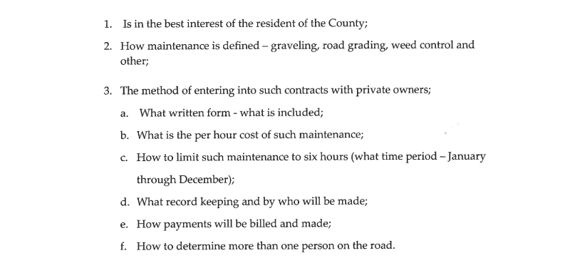
Dated this 7th day of February 7, 2023.

Debra Morrison
Buffalo County Auditor
605-293-3217

Published twice at the approximate cost of $
Publish twice February ____ & ______, 2023

