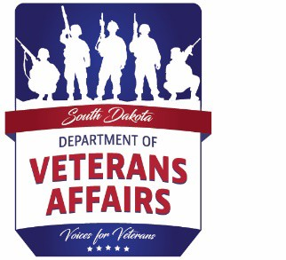

South Dakota Department of Veterans Affairs Soldiers and Sailors Building

425 E. Capitol Avenue Pierre, SD 57501

Phone: 605-773-8242

Fax: 605-773-5380

[http://vetaffairs.sd.gov](http://vetaffairs.sd.gov/)

**FOR RELEASE**: Wednesday, March 13, 2024

**For more information, contact**: Audry Ricketts at 605-773-8242 or [audry.ricketts@state.sd.us](mailto:audry.ricketts@state.sd.us) (South Dakota Department of Veterans Affairs)

Veterans, See What’s Brewing!

PIERRE, S.D. **–** The South Dakota Department of Veterans Affairs will be hosting a “Coffee and Conversation” program in Chamberlain. This program is in partnership with Brule, Buffalo, Jones and Lyman County Veterans Service Officer Tim Thomas. The department welcomes the opportunity to visit one-on-one with veterans and see what’s brewing!

The “What’s Brewing” program will be held Thursday, April 4, at the Chamberlain Community Center (112 N. Main Street) at 1:00 pm (CT).

“’What’s Brewing’ is a great opportunity for us to visit with veterans and hear about the challenges they might be experiencing first-hand. These programs also allow us the opportunity to speak with them about new benefits and services,” said SDDVA Secretary Greg Whitlock. “As the advocates for South Dakota veterans, we need to hear about the things our veterans are facing. We walk among veterans every day, and yet we may not even realize the magnitude of their sacrifices to serve our country.”

The SDDVA team and CVSO Thomas will address questions about veteran’s benefits including compensation, education, pension, healthcare, burial, state veterans cemetery, and state veterans home.

We encourage veterans to join us if they can. As always, they can reach our SDDVA team at 605.333.6869, or they can locate their county or tribal veterans service officer by visiting <https://vetaffairs.sd.gov/veteransserviceofficers/locatevso.aspx>.

-30-