Tuesday, July 2, 2024 - MINUTES OF THE BOARD OF BUFFALO COUNTY COMMISSIONERS
Chairman Dawn Cable called the meeting to order at 2:00pm with Vice-Chair Donita Loudner and Commissioner Rex Zastrow present.
Also present were Steve Larson, Deputy States Attorney; Debi Ruiz, Central Dakota Times; Debra Morrison, Buffalo County Auditor; and several citizens.
Pledge of Allegiance was recited.
Loudner moved to accept the agenda; seconded by Zastrow. Motion carried by all voting Aye.
Loudner moved to approve the minutes of June 18 and 25, 2024; seconded by Zastrow. Motion carried by all voting Aye.
Buffalo County Highway Superintendent Tanner Grohs addressed the commission. Zastrow made a motion to approve the Fuel bid from Total Oil, Inc. for Unleaded Bulk Price @ $3.48; Ethanol Bulk Price @ $3.05; #1 Dyed Bulk Price Prem @ $N/A, and #2 Dyed Bulk Price Prem @ $3.10; Zastrow second. Motion carried by all voting Aye.
Loudner made a motion to authorize Bridge improvement Grant/Local Federal Bridge Program Resolution 2024-07 Submission of application for Structure # 09-240-135 Located 5.0 miles west and 2.5 miles south of Gann Valley; seconded by Zastrow. Motion carried by all voting Aye.
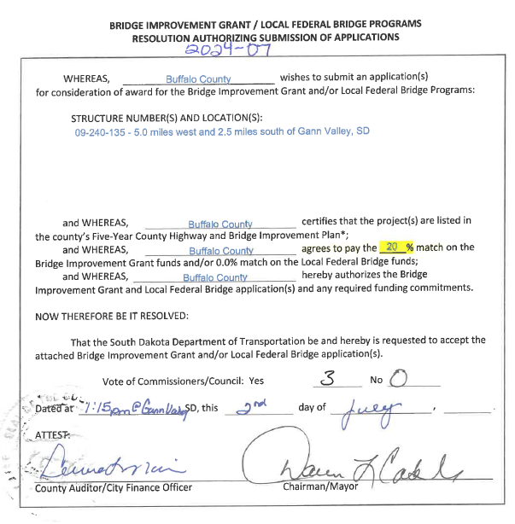
Director of Equalization/911/Weed and Pest Supervisor Lee Sinkie addressed the commission. No action taken.
Auditor/ROD Debra Morrison gave her report. One hospitalizations/billing to report. Auditor/Treasurer April report reflects Total Cash & Cash items: $400.00, Bank Balances: $1,939,785.50, C.D. Miller: $200,000.00.
Morrison discussed Buffalo County SBI Loss Control Consultant Matthey Peterson; corrections were completed and sent back per Morrison. No action taken.

Morrison discussed Aflac Representative Shon Ford. No action taken.

Morrison discussed upcoming trainings/meetings. No action taken.

Loudner made a motion to approve vouchers; seconded by Zastrow. Motion carried by all voting Aye.
Payroll and Reimbursements (please note these numbers are GROSS salaries)
Commissioner $840.00 Commissioner $840.00
Commissioner $840.00 Auditor $3500.00
Treasurer $3675.00 State Attorney $3432.71
Weed & Pest $250.00 DOE $3108.00
Sheriff $4583.33 HWY Superintendent $4666.67
HWY $4900.00 HWY $4846.00
--Total Regular Hours: 548----Totals Payroll: $35,481.71----- Total Reimbursements: $287.81----
Wellmark $7584.26 Division of CS $91.00
AFLAC $233.86 SDRS $3726.82
BEAM $578.95 MASA $140.00
Quoin Bank/Payroll $7616.00
----------Total Payroll Deduction: $19,970.89---------
Buffalo County Fire $224.12 Chamberlain School $19,926.25
Kimball Ambulance $62.96 Kimball School $941.42
South Center Water $273.92 SDDOR $23,760.40
SDACO $14.00 Wessington Springs School $21,861.41
----------------TOTAL CLAIMS $67,064.48-----------------
Aurora-Brule Water $56.25 Amkota $74.99
Bakers Repair $85.95 Brule County $4,031.00
Budde Septic $520.00 C Electric $387.52
EcoLab $78.15 Elvira $756.02
ES&S $1,583.68 Group Sources $88.00
IMEG $4,211.93 J&M $251.52
Jim Anderson $73.72 SDDOLA $202.10
Marco $393.66 Menards $36.49
Debra Morrison $57.28 Nutrient Ag $9,845.55
Quill $607.12 Ramkota $107.00
Sanford Health $112.00 BIT $6.25
SDACC $87.00 Karen Sinkie $71.68
Dulcy Sinkie $400.00 Ellen Speck $63.01
T-Mobile $15.00 Thomson Reuters $580.89
Total Oil $3,051.53 TrueNorth $1,348.05
Kathy Yost $85.96
-------------------TOTAL Claims $29,269.30--------------

Upcoming meeting – 2024 Commissioners Provisional Budget July 23, 2024, at 1:00pm; Commissioners Meeting August 6, 2024, at 1:00pm
Zastrow made a motion to adjourn the Regular July Commissioners meeting; seconded by Loudner. Motion carried by all voting Aye.

